Bulk Extension Update Integration – Implementation
Implemented by - Vaishali Singh

Objective
Implemented a catalog-based integration solution to process bulk extension detail updates using Excel files between two ServiceNow instances.
The solution automates the process of:
- Receiving Excel files from Source Instance
- Transferring files securely through REST integration
- Creating catalog requests automatically
- Parsing Excel attachments
- Updating extension records in the target table

Solution Overview

Source Instance (Instance A)
The source instance is responsible for:
- Accepting/uploading Excel files
- Converting attachment data into Base64 format
- Sending payload to Target Instance through REST Message

Payload Includes
- Customer Name
- Pilot Number
- File Name
- Base64 Encoded Excel File

Target Instance (Instance B)
The target instance is responsible for:
- Receiving REST payload
- Creating catalog request automatically
- Attaching Excel file to generated RITM
- Processing Excel attachment
- Updating Extension Details table records

Implemented Components

1. Catalog Item
A catalog item named:
Change Extension Detail
was configured with:
- Request Type selection
- Customer Name
- Pilot Number
- Excel Attachment support

2. Scripted REST API
A custom Scripted REST API was implemented to:
- Receive payload from Source Instance
- Decode Base64 attachment
- Create catalog request dynamically
- Attach Excel file to generated RITM

3. REST Integration
REST Message integration was configured to:
- Transfer Excel data securely between instances
- Support large attachment payloads
- Enable automated request generation

4. Attachment Processing
A Business Rule on:
sys_attachment
was implemented to:
- Detect uploaded Excel files
- Read attachment stream
- Trigger Excel parsing process

5. Excel Parsing
Implemented using:
GlideExcelParser
The parser:
- Reads each Excel row
- Extracts:
  - Extension Number
  - Display Name
- Validates row data
- Skips empty/invalid rows

6. Extension Table Update
The integration updates records in:
u_extension_details
Update logic:
- Match record using Extension Number
- Update Display Name dynamically
- Log processed records for audit/reference

Excel Template Format
The Excel file must contain the following columns:
extension_number | display_name
1001 | John
1002 | David
1003 | Vaishu
Notes:
- Column names must match exactly
- Extra spaces in headers are not supported
- .xlsx format only

Processing Flow
INSTANCE A (SOURCE)
-------------------
Excel Upload
↓
Convert Attachment to Base64
↓
REST Message
↓

INSTANCE B (TARGET)
-------------------
Scripted REST API
↓
Create Catalog Request
↓
Attach Excel File
↓
Business Rule on Attachment
↓
Parse Excel
↓
Update Extension Table

Outcome
Successfully implemented:
- Automated bulk extension update process
- Excel-based integration between ServiceNow instances
- Dynamic catalog request generation
- Automated attachment processing
- Bulk update capability with minimal manual intervention

Benefits
- Reduced manual effort
- Faster bulk processing
- Scalable integration architecture
- Reusable API framework
- Centralized request tracking
- Improved operational efficiency

Note
Single Extension update capability is also supported within the same catalog framework and can be enabled separately for direct individual extension updates without Excel attachment processing.

Catalog Item with fields like:
- Extension Number
- Display Number / Display Name
And requests will come from external system via Scripted REST API integration.
Your requirement is:

Single Request
External system sends:
- Extension Number
- Desired Display Name
Then catalog request should automatically:
- Create RITM
- Populate extension + display name
- Process request

Bulk Request
External system sends:
- Multiple extension numbers
- Multiple display names
Using:
- Excel upload only (.xlsx)
Then system should:
- Read Excel
- Create one request / multiple request items
- Update mapping for each row

INSTANCE A (SOURCE)
-------------------
Table / Attachment
↓
Convert Excel → Base64
↓
REST Message
↓

INSTANCE B (TARGET)
-------------------
Scripted REST API
↓
Create Catalog Request
↓
Attach Excel
↓
BR on sys_attachment
↓
Parse Excel
↓
Update Extension Table

Pdi Implementation

Instance B (https://dev309375.service-now.com)

Catalog Item

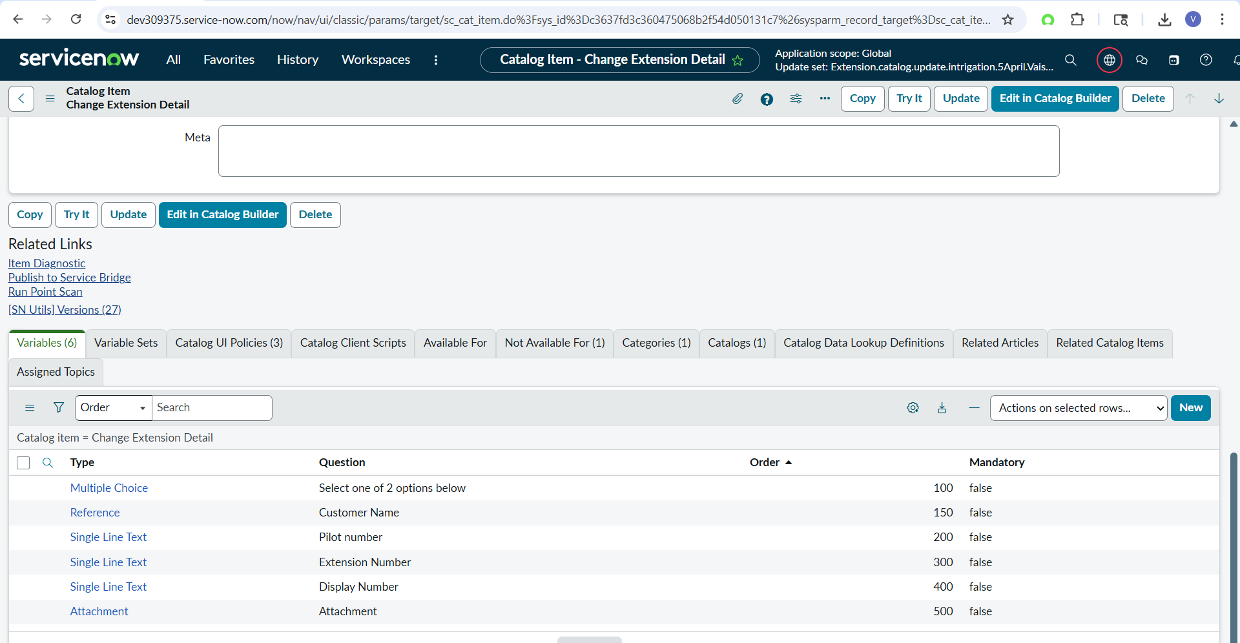
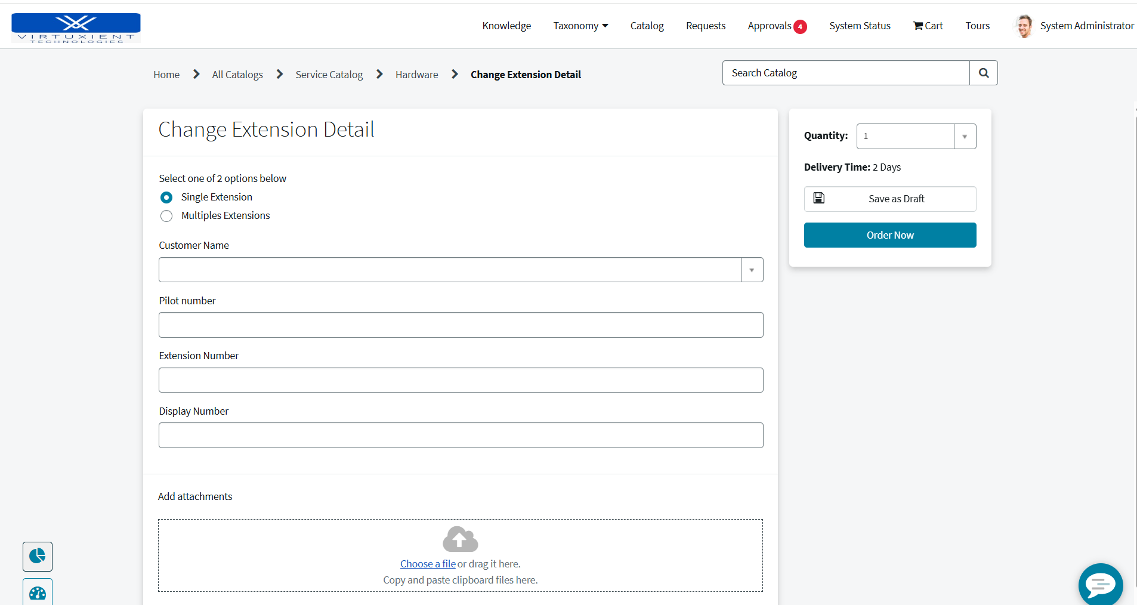
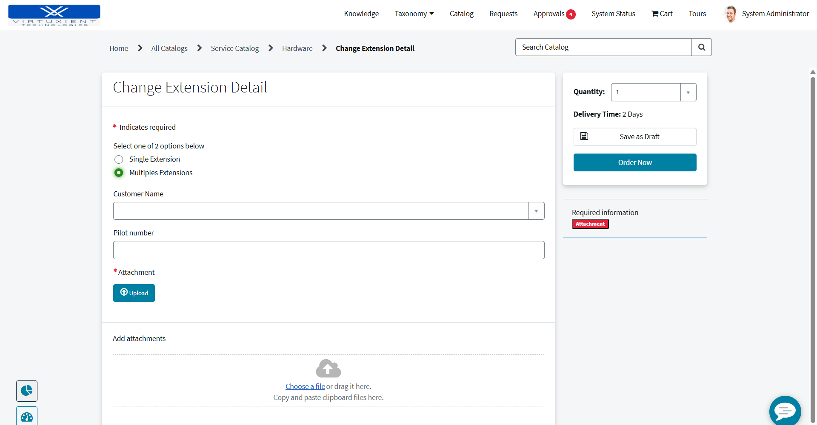

Catalog ui policy
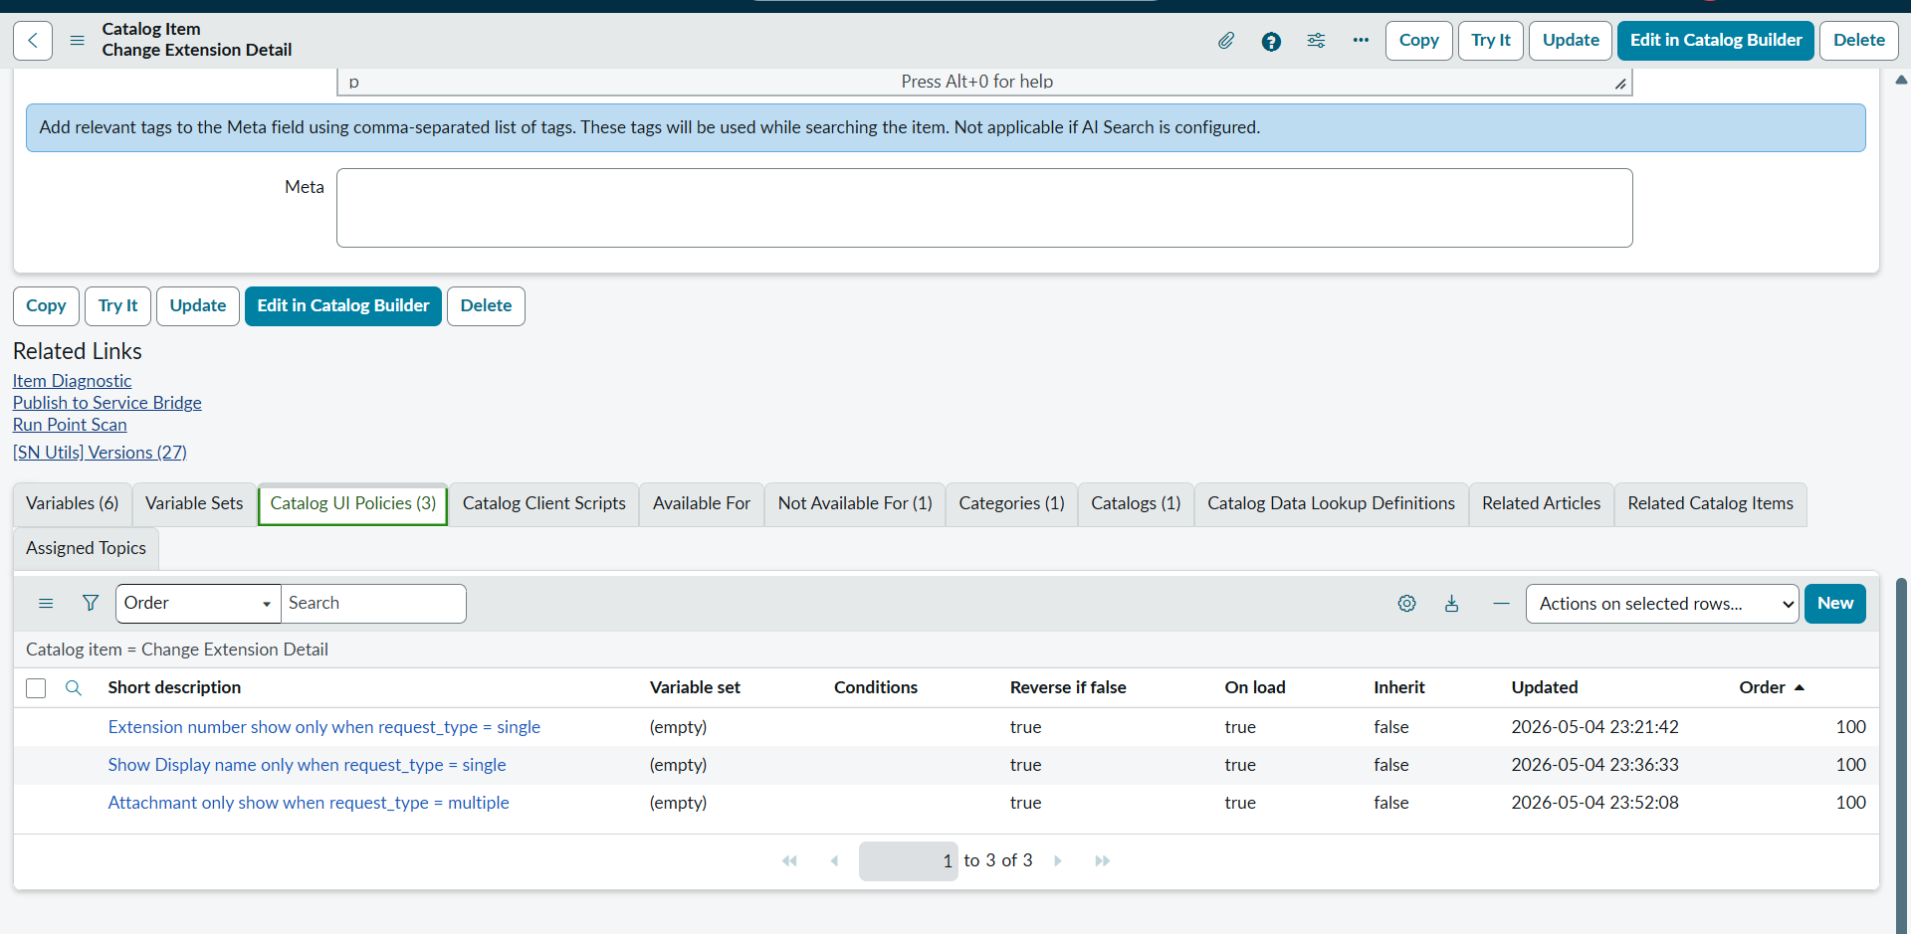

Target table

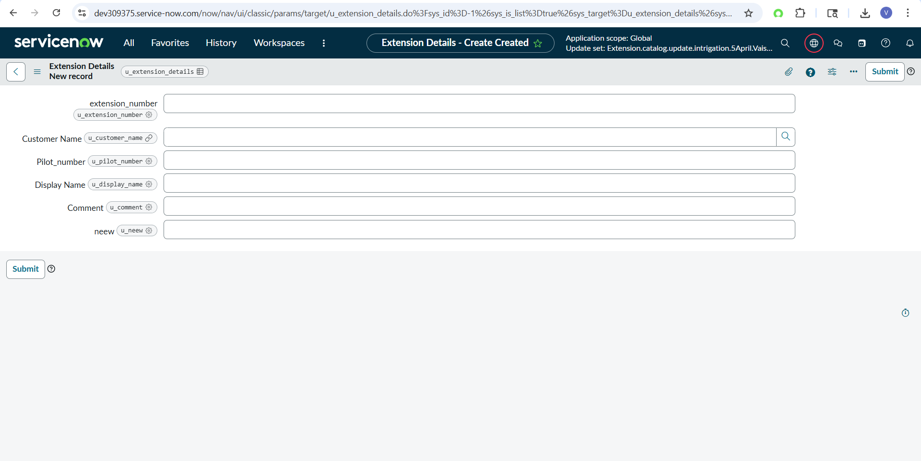

Scripted Rest Api

(function process(/*RESTAPIRequest*/ request, /*RESTAPIResponse*/ response) {
try {
// Read request body
var body = request.body.data;
gs.info('Incoming Payload : ' + JSON.stringify(body));
var customer = body.customer_name;
var pilot = body.pilot_number;
var fileName = body.file_name;
var fileData = body.file_data;
gs.info('Customer : ' + customer);
gs.info('Pilot : ' + pilot);
gs.info('File Name : ' + fileName);
if (!fileData) {
response.setStatus(400);
response.setBody({
status: 'Failed',
error: 'file_data is empty'
});
return;
}
gs.info('Base64 Length : ' + fileData.length);
// Create Cart
var cart = new Cart();
// Add Catalog Item
var item = cart.addItem('c3637fd3c360475068b2f54d050131c7');
// Set Variables
cart.setVariable(item, 'select_one_of_2_options_below', 'multiple');
cart.setVariable(item, 'customer_name', customer);
cart.setVariable(item, 'pilot_number', pilot);
// Place Order
var rc = cart.placeOrder();
gs.info('Request Created : ' + rc.number);
// Get RITM
var ritm = new GlideRecord('sc_req_item');
ritm.addQuery('request', rc.sys_id);
ritm.orderByDesc('sys_created_on');
ritm.setLimit(1);
ritm.query();
if (ritm.next()) {
gs.info('RITM Found : ' + ritm.number);
// Attach Excel File
var attachment = new GlideSysAttachment();
// Decode Base64
var decodedBytes = GlideStringUtil.base64DecodeAsBytes(fileData);
// Write attachment
var attachSysId = attachment.write(
ritm,
fileName,
'application/vnd.openxmlformats-officedocument.spreadsheetml.sheet',
decodedBytes
);
gs.info('Attachment Sys ID : ' + attachSysId);
gs.info('Attachment Sys ID : ' + attachSysId);
response.setStatus(200);
response.setBody({
status: 'Success',
request: rc.number,
ritm: ritm.number,
attachment: attachSysId
});
} else {
response.setStatus(500);
response.setBody({
status: 'Failed',
error: 'RITM not found after order creation'
});
}
} catch (ex) {
gs.error('API Error : ' + ex.message);
response.setStatus(500);
response.setBody({
status: 'Failed',
error: ex.message
});
}
})(request, response);

Business Rule
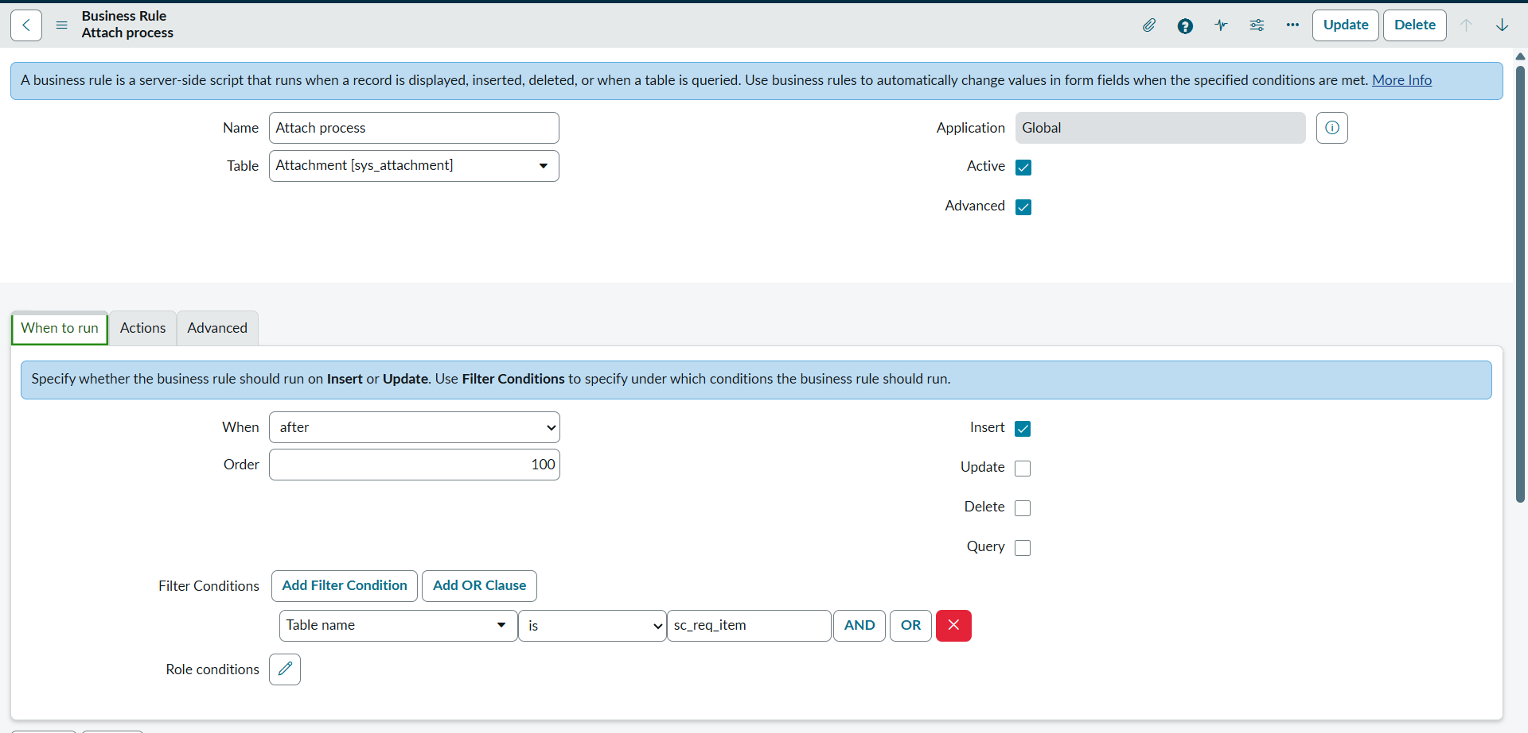

Condition - current.table_name == 'sc_req_item'

Script

(function executeRule(current, previous /*null when async*/) {
try {
gs.info('Attachment Name : ' + current.file_name);
gs.info('Table Name : ' + current.table_name);
// Get RITM
var ritm = new GlideRecord('sc_req_item');
if (!ritm.get(current.table_sys_id)) {
gs.info('RITM not found');
return;
}
gs.info('RITM Found : ' + ritm.number);
// Check catalog item
if (ritm.cat_item != 'c3637fd3c360475068b2f54d050131c7') {
gs.info('Wrong Catalog Item');
return;
}
// Parse Excel
var parser = new sn_impex.GlideExcelParser();
var stream = new GlideSysAttachment()
.getContentStream(current.sys_id);
parser.parse(stream);
gs.info('Excel Parsing Started');
while (parser.next()) {
var row = parser.getRow();
gs.info('Row Data : ' + JSON.stringify(row));
var extension = (row['extension_number '] || row.extension_number || '').trim();
var display = (row.display_name || '').trim();
gs.info('Extension : ' + extension);
gs.info('Display : ' + display);
// Skip empty rows
if (!extension || !display) {
gs.info('Skipping Empty Row');
continue;
}
// Update extension table
var gr = new GlideRecord('u_extension_details');
gr.addQuery('u_extension_number', extension);
gr.query();
if (gr.next()) {
gr.u_display_name = display;
gr.update();
gs.info('Updated Successfully : ' + extension);
} else {
gs.info('Extension Not Found : ' + extension);
}
}
gs.info('=== Excel Processing Completed ===');
} catch (ex) {
gs.error('BR Error : ' + ex.message);
}
})(current, previous);

Instance A

Upload Excel in sys Attachment table

Copy sys id

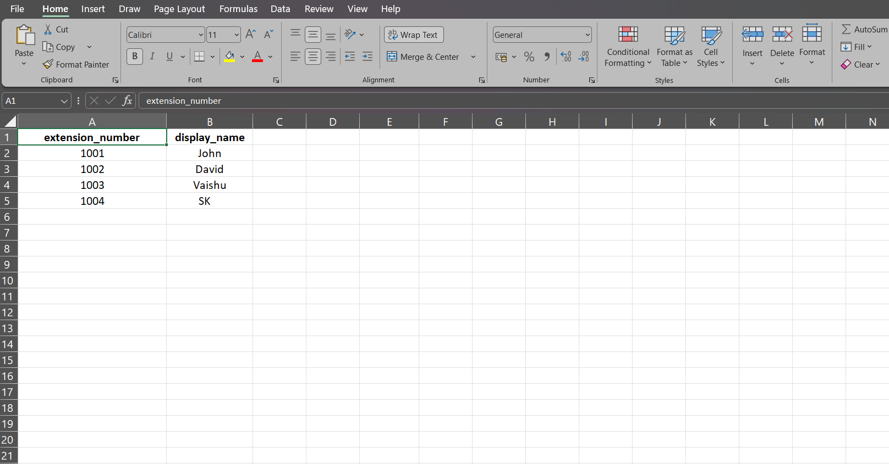

Rest message

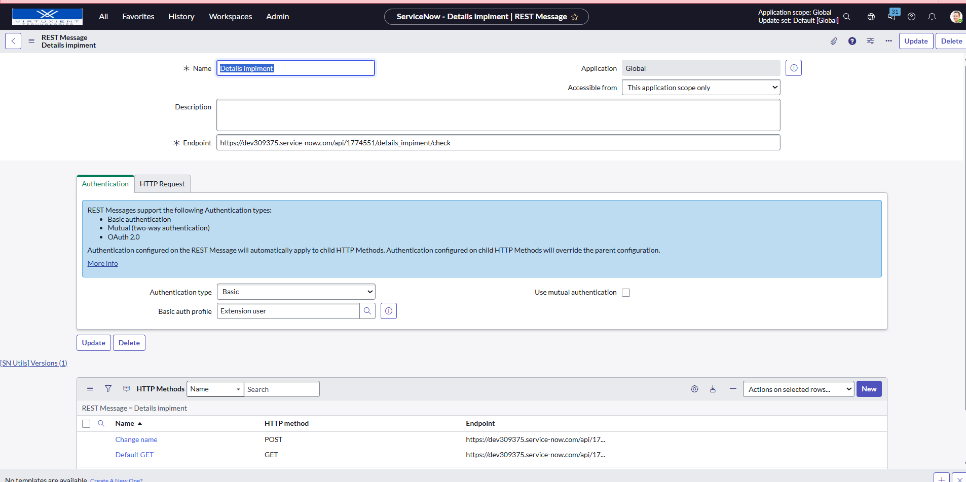

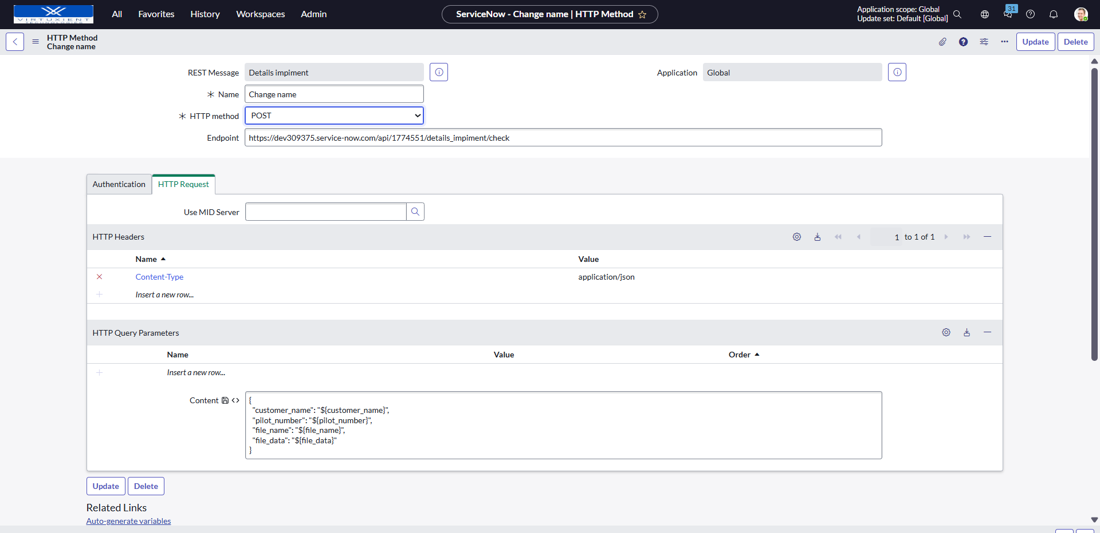

{
"customer_name": "${customer_name}",
"pilot_number": "${pilot_number}",
"file_name": "${file_name}",
"file_data": "${file_data}"
}

Test Run

Via Back ground script

var attachmentSysId = '0b3f6e8047780bd0de6b29af016d4318';

var attachmentGR = new GlideRecord('sys_attachment');

if (attachmentGR.get(attachmentSysId)) {

var gsa = new GlideSysAttachment();

var bytes = gsa.getBytes(attachmentGR);

var base64 = GlideStringUtil.base64Encode(bytes);

var rm = new sn_ws.RESTMessageV2('Details impiment ', 'Change name');

rm.setStringParameterNoEscape('customer_name', 'TEST');

rm.setStringParameterNoEscape('pilot_number', '999934999');

rm.setStringParameterNoEscape('file_name', 'data.xlsx');

rm.setStringParameterNoEscape('file_data', base64);

var response = rm.execute();

gs.info('STATUS : ' + response.getStatusCode());

gs.info('BODY : ' + response.getBody());
}

For verification

var attachmentSysId = 'fe581ac847b40bd0de6b29af016d43d0';

var attachmentGR = new GlideRecord('sys_attachment');

if (attachmentGR.get(attachmentSysId)) {

var gsa = new GlideSysAttachment();

var bytes = gsa.getBytes(attachmentGR);

var base64 = GlideStringUtil.base64Encode(bytes);

gs.info(base64);
}

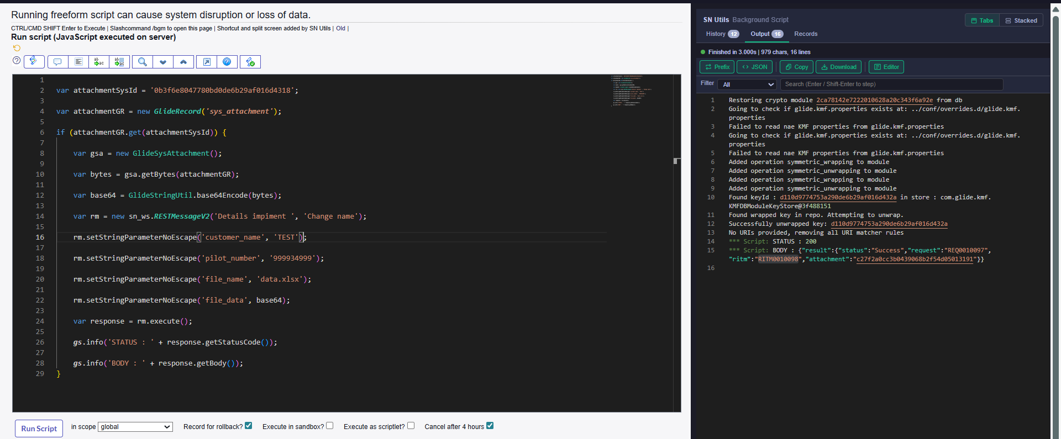

In instance B

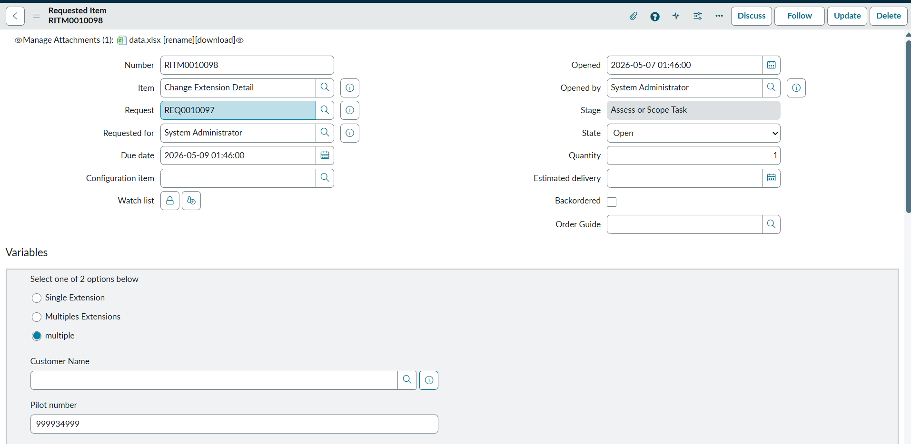

Attachment come successfully

Now in table Successfully update
